Lab 25 - Analyzing Smurf Attack
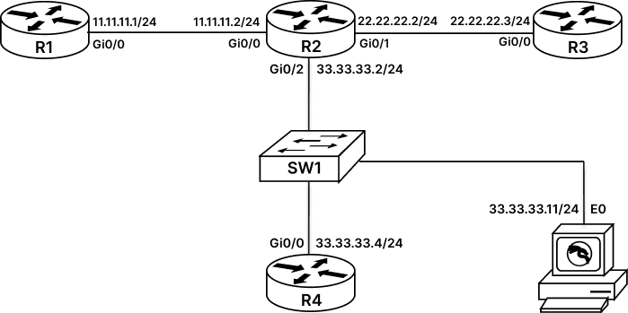

SMURF ATTACK
Smurf Attack is a distributed denial-of-service attack in which attacker uses Internet Control Message Protocol(ICMP) packets with the intended victim’s spoofed IP as the source of ICMP packet to attack group of host in a network by using the broadcast address of the host’s network. By default, most of the machine in a network reply to the source IP address in this case the IP of victim, thus flooding victim with ICMP traffic. This results in slowing down of the victim’s machine.
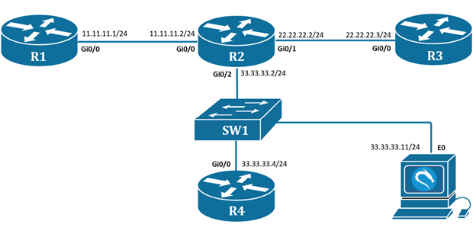
Task 1: Initial Configuration
Step 1: Configure Routers with an IP address.
Note: Kali PC are pre-configured with an IP address of 33.33.33.11.
R1#conf t
R1(config)#int gi0/0
R1(config-if)#ip add 11.11.11.1 255.255.255.0
R1(config-if)#no shutdown
----------------------------------------------------
R2#conf t
R2(config)#int gi0/0
R2(config-if)#ip add 11.11.11.2 255.255.255.0
R2(config-if)#no shutdown
R2(config)#int gi0/1
R2(config-if)#ip add 22.22.22.2 255.255.255.0
R2(config-if)#no shutdown
R2(config)#int gi0/2
R2(config-if)#ip add 33.33.33.2 255.255.255.0
R2(config-if)#no shutdown
-----------------------------------------------------
R3#conf t
R3(config)#int gi0/0
R3(config-if)#ip add 22.22.22.3 255.255.255.0
R3(config-if)#no shutdown
-----------------------------------------------------
R4#conf t
R4(config)#int gi0/0
R4(config-if)#ip add 33.33.33.4 255.255.255.0
R4(config-if)#no shutdown
Step 2: Configure default route on R1,R3 and R4 pointing towards R2 router and verify reachability from R1 to R3,R4 and Kali-PC.
R1#conf t
R1(config)#ip route 0.0.0.0 0.0.0.0 11.11.11.2
-----------------------------------------------------
R3#conf t
R3(config)#ip route 0.0.0.0 0.0.0.0 22.22.22.2
-----------------------------------------------------
R4#conf t
R4(config)#ip route 0.0.0.0 0.0.0.0 33.33.33.2

R1#conf t
R1(config)#ip route 0.0.0.0 0.0.0.0 11.11.11.2

R1#ping 33.33.33.4
type escape sequence to abort.
Sending 5, 100-byte ICMP Echos to 33.33.33.4, timeout is 2 seconds:
!!!!!
Success rate is 100 percent (5/5), round-trip min/avg/max = 7/8/11 ms
R1#
Similarly verify the reachability from R1 to R3 and Kali-PC.
Task 2: Perform Smurf Attack(Reflection):
To perform Smurf Attack, we will need to spoof the IP address of our intended victim which is R3 Router. So on our Attacker Router that is R1, we will first configure a loopback address with spoofed IP of our intended victim.
Step 1: Let us start by configuring loopback interface on R1 router with victims spoofed IP.
R1#conf t
R1(config)#int lo 1
R1(config-if)#ip add 22.22.22.3 255.255.255.0
R1(config-if)#no shut
Step 2: Now we will generate an ICMP request packets from R1 router using the spoofed IP of Victim and send it to R4 Router. As a result, we should see some echo-reply generated on our victim router as the router forwarding these Echo Reply understand R3 is the router with 22.22.22.3 IP address. So, we will first enable debug message on R3 router using “debug ip icmp” command and then we will send ping messages from R1 to R4 using the spoofed IP of our Victim(R3).
R3#debug ip icmp
ICMP packet debugging is on
-------------------------------------------------------
R1#ping 33.33.33.4 source loopback 1
-------------------------------------------------------
Step 3: Now if we check the debug message on R3, it will have some reply coming from R4, resulting in attack. This kind of attack is an example of DOS attack.
R3#
ICMP: echo reply rcvd, source 33.33.33.4, destination 22.22.22.3
ICMP: echo reply rcvd, source 33.33.33.4, destination 22.22.22.3
ICMP: echo reply rcvd, source 33.33.33.4, destination 22.22.22.3
ICMP: echo reply rcvd, source 33.33.33.4, destination 22.22.22.3
ICMP: echo reply rcvd, source 33.33.33.4, destination 22.22.22.3
Task 3: Perform Smurf Attack (Amplification):
By default, a broadcast packet sent to a router will not be forwarded by the router instead it will be dropped. In our scenario, we will simulate this kind of attack by manually enabling directed broadcast on the router receiving the broadcast packet. A directed broadcast is a broadcast message directed to all host in a particular network.
Note: Some Operating Systems like Windows and Linux are not configured to send echo-reply for directed-broadcast request.
Step 1: Enable directed broadcast on R2 routers Gi0/2 to forward broadcast requests from this interface.
R2#conf t
R2(config)#int Gi0/2
R2(config-if)#ip directed-broadcast
Step 2: From R1(Attacker) send ICMP packet for 33.33.33.255 (broadcast IP) by spoofing the IP address of R3(Victim).
R1#ping 33.33.33.255 source loopback 1
Step 3: Verify debug message on R3 router. Here we will see that Attacker has sent one request for everyone in 33.33.33.0 network using the VICTIM IP address. This request is getting reply from all devices in that network. Thus, exhausting more resources on the VICTIM machine. This kind of amplification attack is an example DDOS attack.
Here we can see we are receiving reply from 11.11.11.2( this is the receiving interface of broadcast packet, hence reply packet will be formed via this interfaces), 33.33.33.4(R4 router). We are not receiving any message from Kali PC as it does not participate in directed broadcast.
R3#

ICMP: echo reply rcvd, source 11.11.11.2, destination 22.22.22.3
ICMP: echo reply rcvd, source 33.33.33.4, destination 22.22.22.3
ICMP: echo reply rcvd, source 11.11.11.2, destination 22.22.22.3
ICMP: echo reply rcvd, source 33.33.33.4, destination 22.22.22.3
ICMP: echo reply rcvd, source 11.11.11.2, destination 22.22.22.3
ICMP: echo reply rcvd, source 33.33.33.4, destination 22.22.22.3
ICMP: echo reply rcvd, source 11.11.11.2, destination 22.22.22.3
ICMP: echo reply rcvd, source 33.33.33.4, destination 22.22.22.3
ICMP: echo reply rcvd, source 11.11.11.2, destination 22.22.22.3
ICMP: echo reply rcvd, source 33.33.33.4, destination 22.22.22.3

